**Financial Management Calculators**

*by*

**D SHIVANESH 22MIS1146**

**YASHWANTH S 22MIS1188**

**HARISH D 22MIS1218**

*under the guidance of*

**Dr. B V A N S S PRABHAKAR RAO**

in partial fulfillment of the course

**SWE2007 - Software Construction and Maintenance**



**School of Computer Science and Engineering**

**Vellore Institute of Technology**

**Chennai - 600127**

**November 2024**

**BONAFIDE CERTIFICATE**

Certified that this project report entitled **“Financial Management Calculators”** is a bonafide work of **D SHIVANESH - 22MIS1146, YASHWANTH - 22MIS1188, HARISH D - 22MIS1218** , who carried-out the Project work under my supervision and guidance

**for SWE2007 - Software Construction and Maintenance.**

**Dr. B V A N S S PRABHAKAR RAO**

Professor

School of Computer Science and Engineering (SCOPE),

VIT University, Chennai

Chennai – 600 127.

**TABLE OF CONTENTS**

|  |  |
| --- | --- |
| **S.No** | **Content** |
| **1** | **Abstract** |
| **2** | **Scope** |
| **3** | **Objectives** |
| **4** | **Introduction** |
| **5** | **Modules** |
| **6** | **UML Diagrams** |
| **7** | **Calculators** |
| **8** | **Output** |
| **9** | **Future Work** |
| **10** | **Conclusion** |
| **11** | **References** |
| **12** | **Code** |

**1.ABSTRACT**

The Financial Calculators project will culminate in the creation of a state-of-the-art suite of 15 web-based financial calculators that will help users manage and plan their finances wisely. Some of the tools devised in this project range from simple interest calculation applications like Simple Interest and Compound Interest to retirement planners, SIP calculators, and stock return calculators. Each of the calculators is designed to deliver personal financial computations with, as appropriate, in-flationary adjustments and real-world data for relevance and accuracy.The project was done on Flask backend side and HTML/CSS on frontend side of design, it delivers accessibility and usability. The application calculators come in handy for various needs in financial planning be it on returns of investments, savings goals, loan analysis, currency conversion, and hence helps one make proper financial decision. The project also relates real-time inflation data for some of the calculators, making projections more accurate. In addition, the input investment and projected returns over time are graphically shown by interactive graphs that give users the ability to analyze trends and also make changes in their financial planning. These visualizations enhance user engagement, and provide clear intuitive understanding of how investments grow under the different conditions making financial planning, though difficult, more accessible and informative.

1. **Scope**

The scope of the Financial Calculators project is to provide a comprehensive platform with 15 web-based calculators, each targeting different financial needs, such as investment growth, savings, loan analysis, and currency conversion. It includes a group of various calculators, like simple interest, compound interest, SIP, PPF, and retirement planners, which enable users to critically analyze their myriad short-term and long-term decisions. The calculators have user-friendly interfaces built with HTML and CSS that use Flask for smooth workability. Adjustments based on inflation and real-time data in some of the calculators help make the predictions more accurate, thus making the tool really important for the users who want to know more about their financials and take better financial decisions.

1. **OBJECTIVES**

* **Financial calculators suite**. This will be able to address most other financial planning and investment needs, such as savings, investments, loan analysis, and retirement planning in a wide scope of financial decisions that one might make or has made in his or her lifetime. Various calculators available under one site can easily be used and provided for every specific financial decision a user will need to make.
* **Finance calculators Improve the financial literate skills of users by making easy finance computations and projections available**: Finance calculators take complex financial concepts and more complex computations and allow the users to get a wide understanding of key finance principles. The use of clear interfaces and results explains financial planning with a better understanding by the users, thus improving their abilities to make better decisions.
* **To enable users to make informed savings, investments, and loan decisions with actual, real-time data whenever available**: In the suite, a few calculators give real-time updates on inflation and financial data. As such, any computation or calculation would reflect the actual economic conditions. Because of this, decisions made are best at using relevant and timed information; thus, securing the financial plans.
* **Development of an easy-to-use, web-based system with accessible interfaces for smooth financial calculations:** The platform is designed in terms of HTML and CSS to make usability simple with an emphasis on simplicity. This would enable users who may not know much about financial calculations to work with the calculators easily and with much ease.
* **Incorporate inflationary adjustments and live financial data** into specific calculators so that there will be an actual projection. Some of the calculators, such as retirement planning and investment returns, include some sort of inflation adjustment. Live access to accurate data gives the user an actual perspective of what financial outcome may be.

1. **Introduction**

The Financial Calculators project can be used as a multi-purpose toolkit, offering individuals direct access to 15 calculators, which will enable users to handle their finances better and make more informed financial decisions. In periods of rapid change in the economy, understanding the implications of inflation, savings growth, loan payments, and investment returns holds the key to financial security.This project comprises a wide variety of calculators ranging from Simple Interest and Compound Interest to Savings Goal, SIP (Systematic Investment Plan), PPF (Public Provident Fund), Retirement Planner, Currency Converter, Loan Analysis, and many more.

Each of the calculators has a specific financial application that lets the user make different kinds of calculations concerning his particular financial needs and plans. For example, SIP and PPF calculators let the user know the long term projection about the growth of his investment, while the Loan Analysis calculator tells exactly how many more paychecks you have to wait before paying off your loan and what your interest will be. The Retirement Planner, with its brilliant, user-friendly interface, is expected to provide users with an insight into what their future financial needs will be so they are in a better position for their post-retirement years.

Some calculators use real-time information like inflation rates to make the output of projections more meaningful and accurate. The results are, thus complied with the current status of the economy. This is especially useful for investments and retirement planners where the impact of inflation is great on the amount for future values. Real-life financial data are also integrated into such calculators to make projections more realistic and guide users in making better decisions that depend on the trends of the present moment.The back-end used Flask to perfect the transactions and processing of data with calculation. On the other hand, the front-end was in HTML and CSS to be user-friendly. Every calculator is developed in a way that is accessible. Every calculator has a clear layout, intuitive fields, and clear results. This clarity ensures that all users, regardless of financial or technical background, can navigate through the site and enjoy its tools.

Besides that, some calculators display graphs that graphically present the growth of investments or inflation over time. Those graphs help users understand how investment or savings may actually be developing in the future, with an educational input to financial literacy.

1. **Modules**

* **User-Friendly UI/UX:** An interface of every device must be easy to use while using the different types of calculators.
* **Complete Computations:** Multiple calculations are designed to cater for use in relevant cases, including financial, scientific, and statistical kinds.
* **Nearly Accurate Output:** Algorithms or formulas may be used for accurate outputs in myriad diverse situations.
* **Interactive Data Anlaysis:** Further provides detailed analysis, including breakdowns of calculation, summary, and successive result steps.
* **Graphics:** Interactive graphs or charts for easier understanding of trends and results.
* **Error Handling:** Robust error messages in the case of invalid input will make it a great user experience.
* **Real Time results:** Rich integration with AJAX and the like supports instant results without page reload.
* **Scalability:** The architecture of modules allows for the easy integration of new types of calculations and features, thus making long-term usage of this tool feasible.
* **Backend Support:** The integration of a robust backend, such as Flask or Django, ensures that data can be processed effectively and inputs handled securely.

1. **UML Diagrams**

**Class Diagram:**

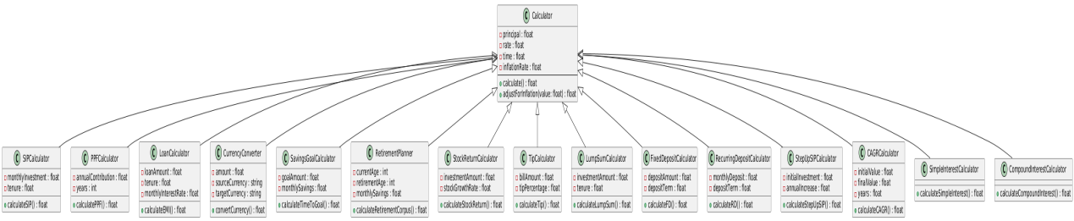

**Activity Diagram:**

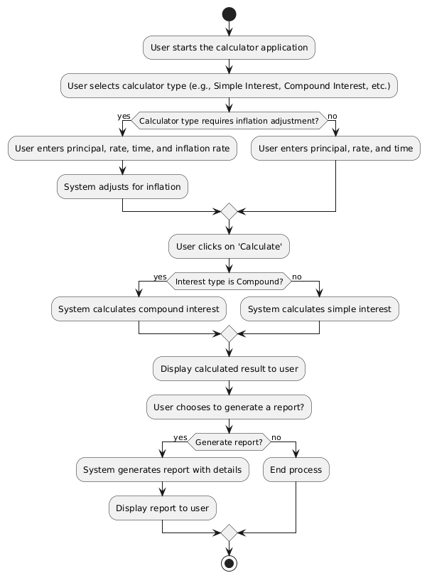

**State Diagram**

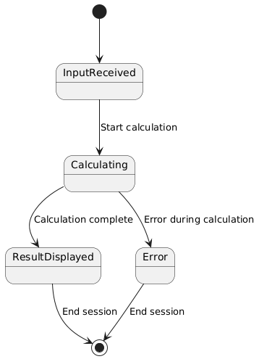

**Sequence Diagram**

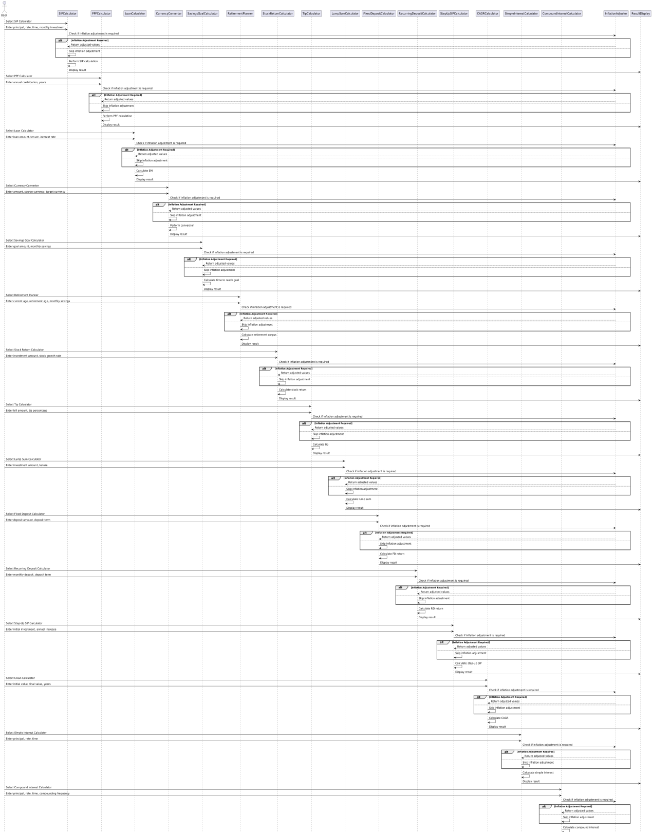



**Component Diagram**

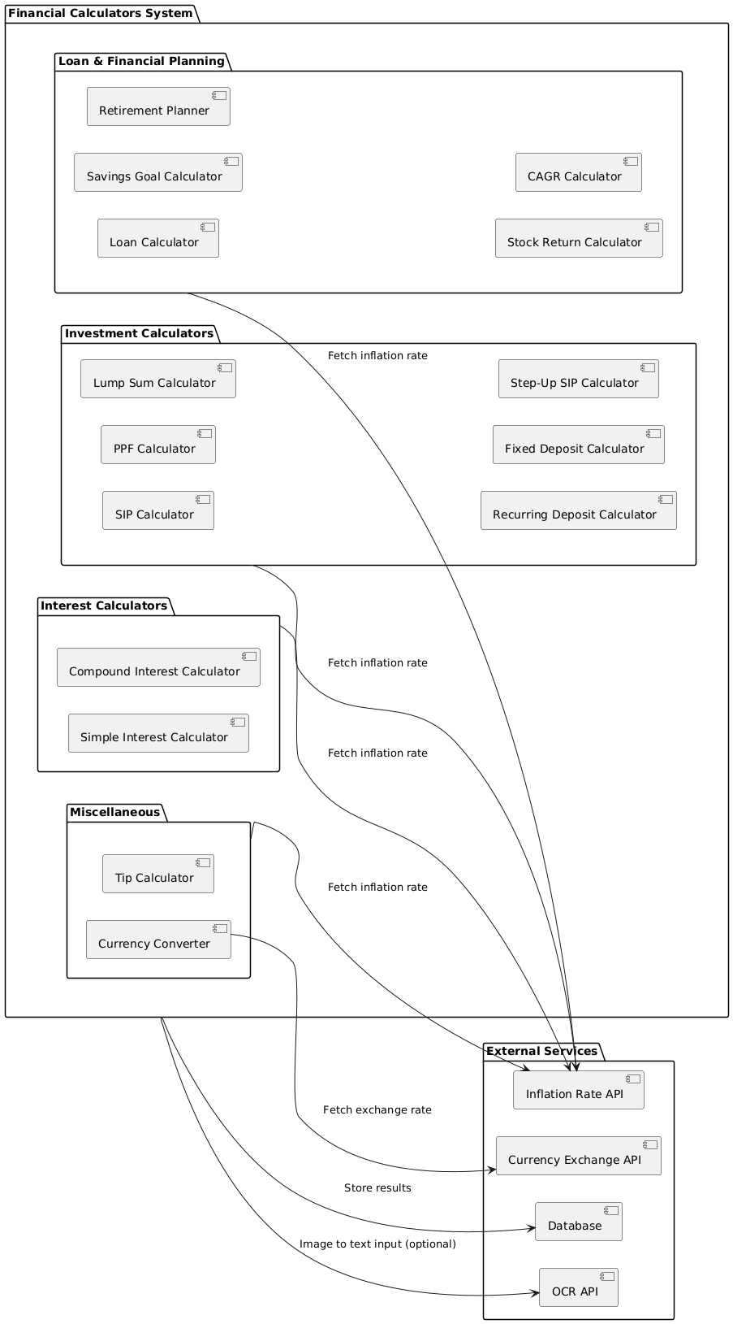

1. **Calculators Details**

* **Currency Converter Calculator :**

The currency converter calculator is a friendly web application, built with Flask. It accepts an amount typed in with a source currency specified and a destination currency. It then fetches real-time exchange rates to convert the entered amount from one currency to another. The application has an in-built API for extracting a list of supported currencies along with their latest conversion rates. If the API does not produce any response, it gives a fallback list of common currencies.

**- Usage :**

Using this application involves specifying the base currency, the currency to be converted from and for, and the amount to convert by filling the order form. After the form is submitted, the application fetches the most recent exchange rate of the base currency and computes the equivalent amount of the target currency.

This robust utility will manage API failure quite well, providing you with real-time rates as well as solid fallbacks and makes a good solution to currency conversions speedily and accurately.

* **Simple Interest Calculator :**

The Simple Interest Calculator is a flask web application for the computation of nominal and inflation-adjusted simple interest. Users input the principal amount, interest rate, time period, and inflation rate. After a successful submission of the form, the calculator proceeds with the computing of the nominal simple interest using the formula (Principal×Rate×Time)/100(Principal times Rate times Time) / 100(Principal×Rate×Time)/100, while the nominal total amount will be calculated adding the interest to the principal.

**- Usage:**

Users can compute simple interest by simply filling up the form with principal amount, rate of interest, time period and inflation rate. When submitted, it computes and returns the nominal interest, total amount, inflation adjusted real interest and real total amount, so that an estimate of return is available not only in nominal but also in real terms.

Results, both in nominal and in real terms appear for convenience of the user. This utility is useful also to understand how inflation influences returns on investments, providing an effective way to compare nominal and real interest. A view with defaulted data is also available for users, who did not submit any data.

* **Compound Interest Calculator:**

The Compound Interest Calculator is a Flask application that calculates compound interest with and without adjustment for inflation. The calculator takes as input, principal amount, interest rate, time period, the inflation rate and a compounding frequency-daily, monthly, quarterly, semi-annually or annually. The calculator calculates the compounding frequency and computes compound interest and total amount using the formula (1 + r/n)^nt. It also inflation-adjustes this by reducing the rate of return and recalculating inflation-adjusted compound interest and the overall amount of money received. The results, including values inflation-adjusted, are printed out as a JSON response for analysis or display, giving a sense of how inflation would have affected investments.

**-Usage :** Enter the principal amount, interest rate, time period, inflation rate, and choose compounding frequency. Click to view the inflation-adjusted compound interest and the total balance, and also to download data for analysis or graphing.

* **Fixed Deposit Calculator :**

Fixed Deposit Calculator A Flask-based application that can calculate the amount received at maturity and an estimated return on the fixed deposit. Users can enter the input principal amount, interest rate, and choose a time period in days, months, or years. Automatically calculates the time period in years for further accurate calculation. It calculates the maturity amount using the formula of quarterly compounding as follows: ((1 + r/4)^{4t}), where the variables involved are rate of interest, and time in years. The returns obtained from total returns by subtracting principal value from maturity amount and results are presented along with a pie chart that depicts the invested value and maturity value. The tool allows for error-friendly input by validating the input and returning errors in case invalid data had been entered.  
  
- **Usage:**  
Simply fill in the principal amount, interest rate, and time period in days, months, or years. Submit to find the maturity amount and estimated returns using quarterly compounding. With this, you can clearly know your fixed deposit growth within the stipulated time period as well as estimate your returns through a pie chart.

* **Recurring Deposit :**

Recurring Deposit Calculator A Flask application to compute maturity amounts or returns for recurring deposits over inflation. Users input the following: Monthly Deposit Amount, Interest Rate, Tenure Value in months or years, and Inflation Rate. The tenure value is converted into years, and then the investment amount is computed. It then calculates the maturity amount using the compound interest formula, adjusted for inflation as the real returns. The estimated return then calculated by taking away the amount invested from maturity amount. All the calculated values, including the investment amounts, maturity amount, and returns are rounded off to make it easy to interpret them. Further, it also checks the input values, and error messages are given in case of invalid input in order to ensure correctness and use.

**- Usage :**  
Fill in the monthly deposit, interest rate, tenure in months or years, and inflation rate. Submit the form to get the invested amount, inflation-adjusted maturity amount, and estimated returns. This application will enable users to assess growths on fixed deposits efficiently since it takes into account the inflationary effect for effective clearification of the projections of both real and nominal return.

* **Savings Goal Calculator:**

The Savings Goal Calculator is a simple Flask application that computes how long it will take to arrive at a savings goal with inflation and compound interest. It requires users to input their goal amount, monthly contribution, annual interest rate, and inflation rate. It offsets the savings goal against inflation over time, and converts annual rates into monthly rates for the exact computation. It calculates the number of months to achieve the inflation-adjusted target, the total amount invested, and the estimated returns. The result provides a duration in years and months and an interest table that shows investments, interest earned and total balance for each month. This tool becomes perfect to plan long-term savings by incorporating the effects of both inflation and interest. Of course, it breaks down information line by line but at the same time delivers an overall savings growth summary.  
-**Usage :**  
Input the savings goal, monthly saving, annual interest rate, and inflation rate. Then click this button to find out how many months it will be before you hit your savings goal. Here are the results as years and months, with total invested so far, estimated returns, and a table of the interest table month by month. This tool is perfect for those looking to plan their saving in a more realistic way, taking into consideration the mighty inflation and interest.

* **Loan Analysis Calculator :**

Loan Analysis Calculator is a Flask tool that supplies analysis and computation for different loan aspects such as the amount paid monthly, total loan, and loan terms. Using this tool, a user can choose any one of the three calculation options, which would be either monthly pay, loan, or loan term. Users may input details concerning the loan, including loan amount, annual interest rate, loan duration, which may be either years or months, and the monthly payments if available. These values have mathematical formulas that can be calculated based on the chosen calculation.

For loan amount, it calculates how much loan one can afford in a month based on a fixed monthly payment. For loan term, it calculates how long it will take for the loan to be repaid considering a given loan amount, interest rate, and monthly payment.

In summary, it shows total payments, total interest, and even gives a year-by-year or month-by-month breakdown of loan payments. Results show principal and interest distribution. This loan calculator makes the process of planning less complicated for a user because it comes up with actionable inputs through which people can make informed financial decisions.

**- Usage:**

Pick which result you need: payment, loan amount, or number of payments. Enter any information you know to calculate from-one of loan amount, interest rate, term in years, or payment. Click and see your answer returned as part of a package that may include total payments, interest paid, and a pay-off schedule. Results are returned as JSON data, or can be displayed on the page, including payment details and summaries to act upon. This tool can be used in analyzing the affordability of loans. It may present repayment schedules or estimate the necessary monthly payments from different financial scenarios.

* **Retirement Planner:**

A Retirement Planner is an online calculator to determine the amount one must save each month, so a retirement goal may be achieved as well as how much money will accumulate after a certain number of years. There are three main options available:  
Monthly Savings Needed: This computes the number of dollars to be invested every month in order to meet a targeted retirement sum based on a principal balance, annual rate of return and a number of years until retiring.  
Retirement Amount: Adds up how much there will be at retirement based on a current savings balance, monthly contributions, and an assumed annual return.  
Years Until Retirement: Calculates how many years it will take to accumulate a specified retirement amount based on current savings, monthly contributions, and expected rate of return.  
The compound interest rates determine the formula calculations, with the monthly rate being calculated as an annual percentage. Other than performing this calculation, the tool also provides for normal exceptions in invalid input, keeping the user informed of a problem with their data. The results are then returned in a message format, either on the page or as a JSON response. This will enable the users to better decide on their retirement savings strategies.  
- **Usage :**

Three inputs are provided to compute, which include either saving monthly needs, the retirement amount, or years until retirement. The user needs to input current savings, annual return rate, monthly savings, and desired retirement amount; the tool computes the result, giving it in an easy format in one message or JSON response. It helps the users plan better for their retirement through how much they will save monthly, how much they will have at retirement, or for how long it will take them to achieve their retirement goal.

* **Stock Return Calculator :**

The Stock Return Calculator will determine the profit or loss throughout a stock transaction by considering the costs and taxes. One should only input the buy and sell prices and quantities, and the calculator will deduce the following:

Invested Amount: The amount of money spent on the stocks.

Gross Return: The net difference between the sell amount and the amount invested.

Net Return: The profit or loss that has been calculated after taxes and charges.

Gross and Net Return Percentages: Return expressed as a percentage of the amount invested.

Applicable taxes such as STT/CTT, transaction charges, stamp duty, DP charges, and GST are adjusted from gross return to arrive at net return. The output is provided with break-ups of tax details.

**- Usage :**

The Stock Return Calculator is an aid for working out the profit percentage arrived at from any stock trade, once applicable taxes and other charges are adjusted. It takes the buy and sell prices and quantities from users, after which the tool calculates the amount invested and gross return along with the net return and the percentages corresponding to them. All the taxes are found, including STT/CTT, transaction charges, stamp duty, DP charges, and GST. From the gross return, the net return is obtained by deducting the said taxes from the gross return. Results are displayed in a crystal-clear manner, showing full break of the profitability of a transaction.

* **Tip Calculator:**

The Tip Calculator is one kind of web application that calculates the meal tips. It also states who has to pay for what in case of splitting the bill into portions. The site needs three main inputs, which are: the amount of the total bill, the percentage for tips, and the number of people splitting the bill. The tool makes a number of calculations.

Total Tip: It calculates the amount of the tip based on the tip percent on the check.

Total Check: It adds the total of the check and the calculated tip amount to provide the amount to be paid.

Each Pay Amount: It divides the total of the check by the number of individuals present to show the full amount that each person should pay, including his share of the tip.

Each Pay (Tip): It also calculates how much the tip each member should pay

Returns: all results in JSON, showing the total tip, the total check, what each person would need to pay if including the tip, and how much each member would pay of the tip as far as that goes This is a pretty rudimentary bill splitter and tip estimator.

**- Usage:**

This Calculator Calculates a Tip for a Meal the amount of the tip for a meal is calculated using the total of the bill, the percentage of the tip, and the number of people paying the bill. The calculator will then figure out the total for the tip, the total for the bill with the included tip, and how much each person owes. Results are returned in a user-friendly format: total tip, total check-or as others would call it, bill + tip, and split both by bill and by tip. It's very useful for multiple people to split the cost of a meal when dining in a group. Results are returned in JSON.

* **Lumpsum Calculator:**

The Lumpsum Calculator is a financial calculator that determines the future value of an investment from a given lump sum, computed on an annual rate of return and for a tenure in a specified duration. It also takes the power of inflation into the calculation, thereby giving a true picture of the real future value. The calculator takes four basic inputs: initial investment, annual rate of return, years until tenure, and the inflation rate. It has calculated the future value of an investment with compound interest formula at the end of a given tenure period and also shown to provide an account for inflation in future values, which indeed reflect how erosion of purchasing power happens over time due to inflation. It is an indexed value that provides a sharper understanding of the true value of the investment once the inflationary effect has been taken into account. The future value and adjusted future value in rupees is presented to the reader. This tool enables the user to make very rational, informed financial decisions based on how his investments are affected by the provisions of inflation.

**- Usage :**

You would then be asked to input the initial investment amount, annual rate of return as percentage, tenure, and inflation rate also as a percentage. On hitting the submit button, it calculates the future value and inflation-adjusted future value of your lumpsum investment. The results thus obtained will be in the denominator of rupees. The outcomes will enable you to understand real returns on investments after taking into consideration the inflation over time periods.

* **SIP Calculator :**

With the SIP Calculator, a user is able to calculate the future value of their investment in the systematic investment plan with regard to the expected rate of return, inflation, and frequency of deposits. The key details are then fed into the information bar at the top; a significant part of this would be the monthly deposit amount, expected rate of return, number of years for the tenure, and then the percentage inflation rate. It is also possible for the user to choose the frequency of deposit - either monthly or yearly. After validating the inputs, it calculates the future value of the investment based on the formula that involves inflation-adjusted returns. It further computes the total deposited during the investment period and the total earnings, which is the sum of the future value and the total deposited amount. The result is displayed to the user in a user-friendly format wherein the amounts are converted to lakhs, crores, or thousands for better readability. This tool is applied in learning how periodic investments compounded with time can increase, helping users guide themselves during planning and make informed investment choices.

**- Usage :**  
Enter monthly investment, expected rate of return, tenure of investment in years, and inflation rate. Enter choice whether investments are monthly or yearly. It will then calculate the future value, total amount invested, and total earnings, inflation-adjusted. It then displays results with an understandable format using lakhs, crores, or thousands for the total value, according to the amount.

* **Step - Up SIP Calculator :**

The Step-Up Calculator helps the user plan to invest with growth in the investment by means of an increasing monthly contribution. This calculator also gives the future value of an investment, considering all the following inputs: growth rate, rate of return, investment tenures, and inflation rates. Details such as initial investment, rate of return, growth rate, and tenure have to be entered by the user. The growth rate increases the amount of monthly investment every year and lets it work for the whole tenure period with compounded interest. Then calculate the future value applying the rate of return for the monthly compounding and for inflationary factors. The calculator calculates the total corpus value at the end of the investment period and returns the total earnings-the difference between the future value and the sum invested. The results will come out in easily understandable formats like lakhs, crores, or thousands, depending upon the total value. This calculator is useful for long-term investments where users want to gradually increase contribution.

**- Usage :**

Input the monthly investment amount, rate of return, growth rate, or annum increase in investment, tenure and inflation rate in the Step-up Calculator. The calculator will calculate future value with compound interest, inflation, and increasing month on month investments. Results are displayed in total earnings, total corpus value, and the adjusted corpus value with the addition of inflation. Results are formatted in lakhs and crores for easier consumption.

* **CAGR Calculator**

The CAGR Calculator uses an investment's beginning value, ending value, tenure in an investment in years, and inflation rate supplied by a user. The termination value is indexed for inflation in order to determine the CAGR via the formula: 

The inflation adjusted CAGR means, essentially, the actual rate of growth of the investment in real terms over the period under review. A tenure should be between 1 and 50 years, and invalid inputs will produce a calculator error. Results are presented as a percentage, which lets investors get a proper measure of the real growth of their investments after adjustment for the effects of inflation. This is a tool, which is very important for users wanting to assess long-term investments in terms of the impact on growth from inflation.

**- Usage:**

All you need to do is input the starting value, end value, years of investment, and inflation rate. The calculator then automatically adjusts the end value for inflation to calculate your Compound Annual Growth Rate, or CAGR, with that annualized return after adjusting for inflation. Results are presented as a percentage.

* **PPF Calculator**

The Public Provident Fund calculator computes the amount the maturity value of the future PPF investment will be, using details such as how often one invests, tenure, interest rate, and inflation. Besides investment, the calculator accounts for frequency of investment, tenure in years, and inflation rate. The number of deposits per year is a calculation according to the preferred frequency of investing: monthly, quarterly, semi-annually, or annually. It calculates the maturity amount at the end of the tenure, considering the annual interest rate (7.1% for PPF). It calculates the amount of interest earned and then adjusts the maturity amount for inflation to give the real return on the investment. The figures are formatted in terms of lakhs or crores for better readability. The maturity amount of the investment is illustrated yearly, making it easy for the users to visualize the amount of growth of investment over time.  
**- Usage:**  
All this is possible with the PPF Calculator, which requires a person to input the investment amount, frequency of investment, tenure in years, and rate of inflation. The calculator works out the total deposited, interest earned, and maturity amount after adjusting with the effect of inflation. Results are given in lakhs or crores for easy calculation. The graph tool also breaks down the annual values and interest earned, allowing users to get a deep insight into their growth pattern with time.

1. **OUTPUT**



**--Welcome Page--**

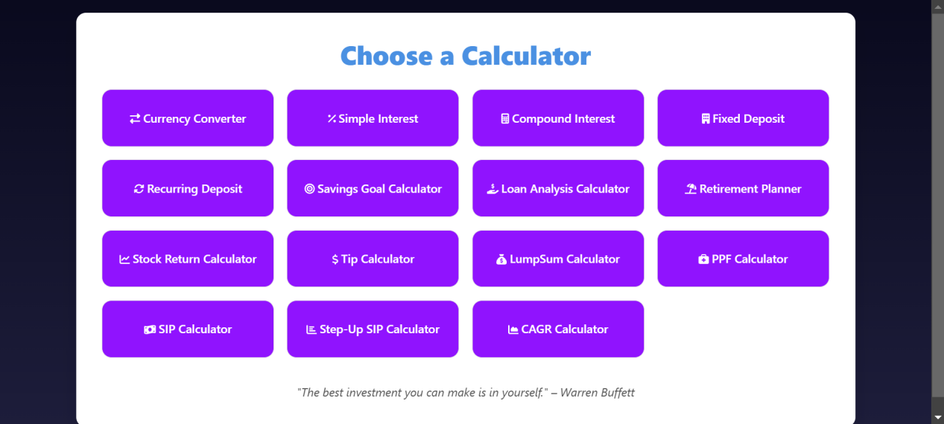

**-- Home Page --**

**- Currency Converter Calculator**

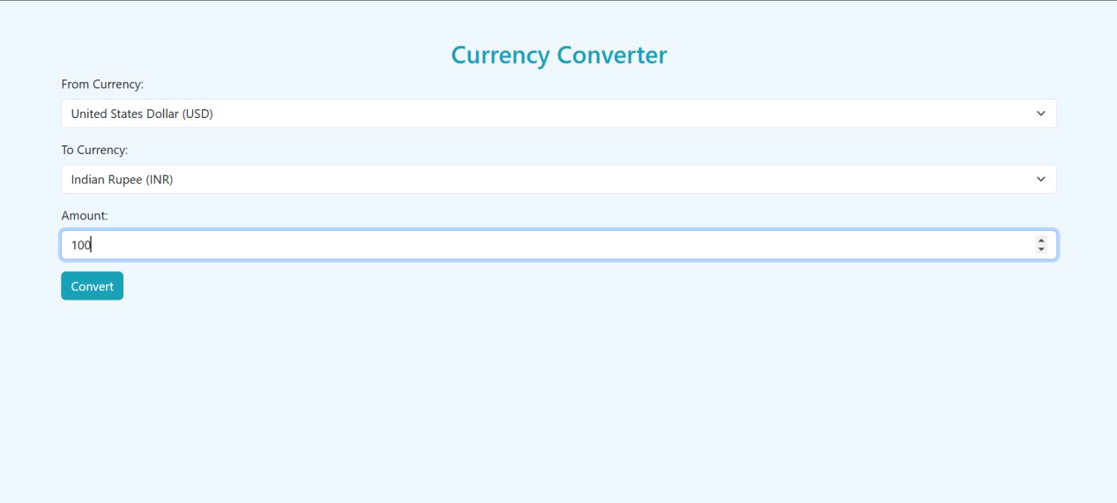

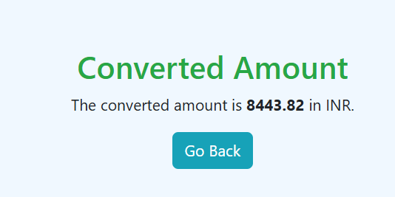

**- Simple Interest Calculator**

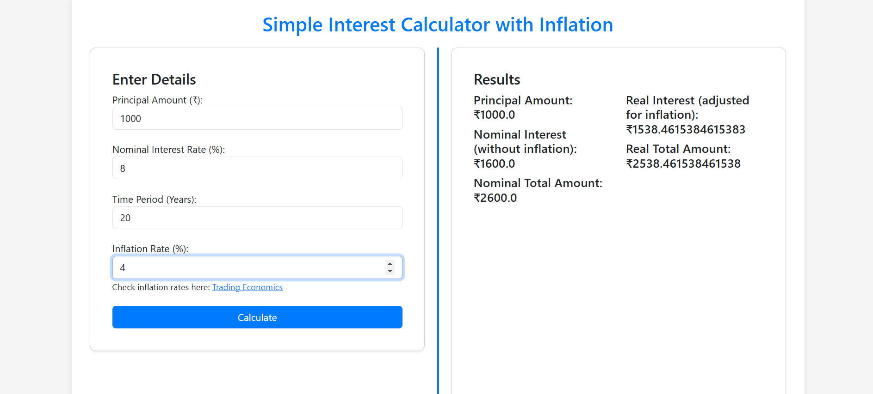

**- Compound Interest Calculator**

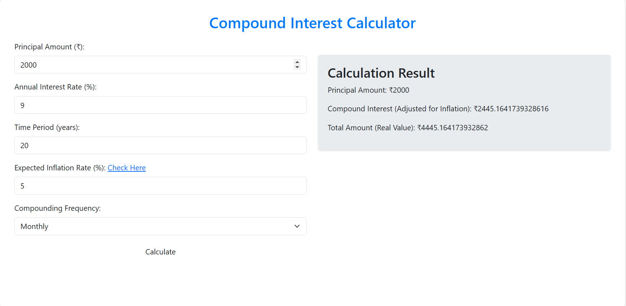

**- Fixed Deposit**

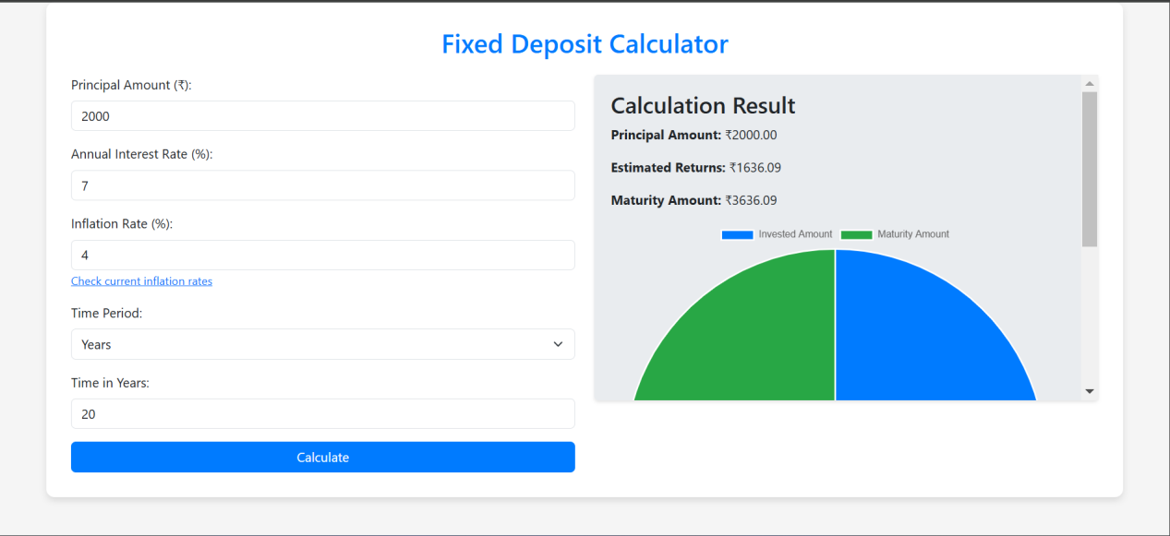

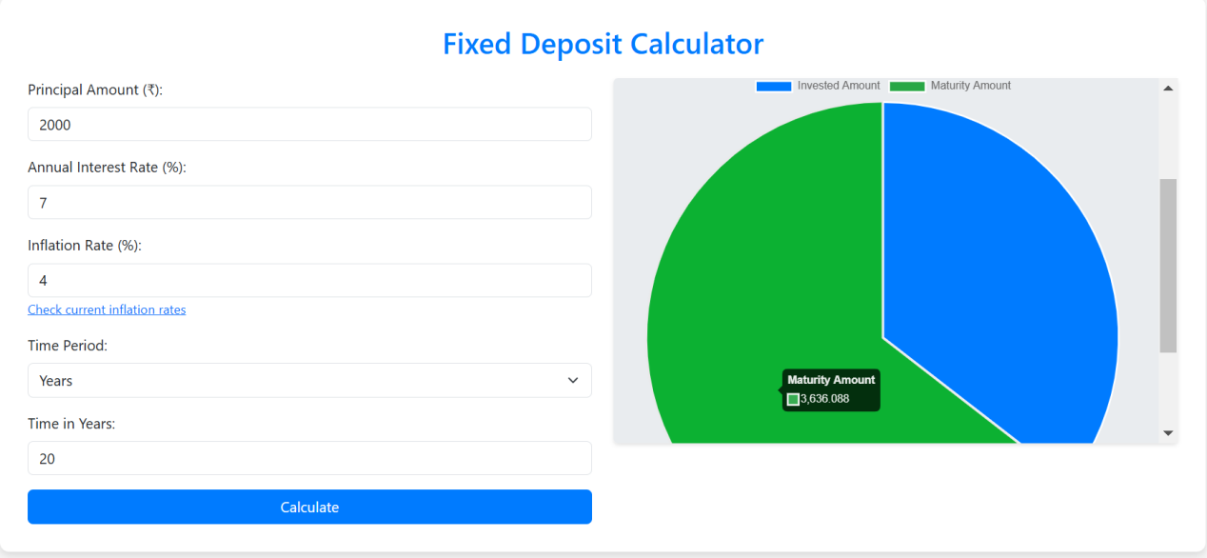

**- Recurring Deposit Calculator**

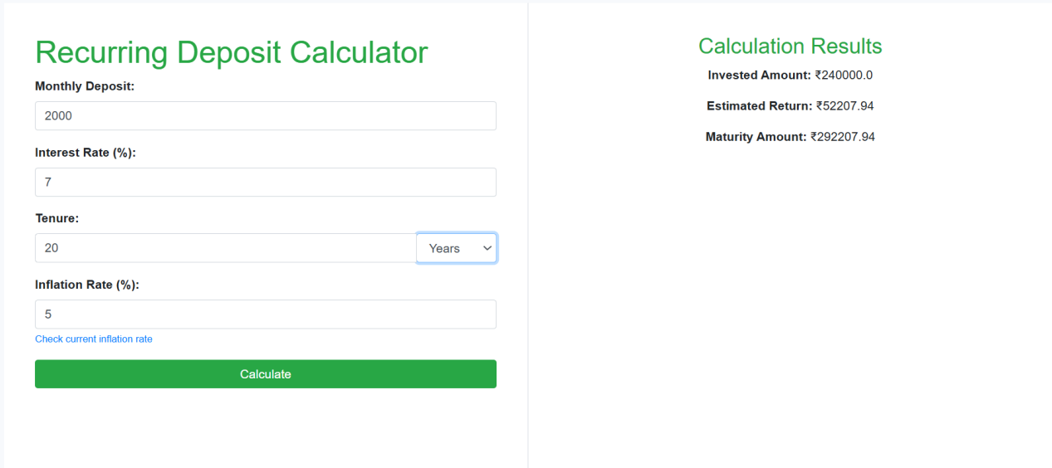

**- Savings Goal Calculator**

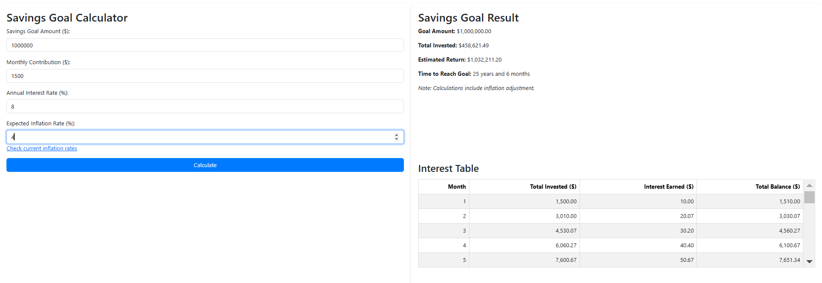

**- Loan Analysis Calculator**

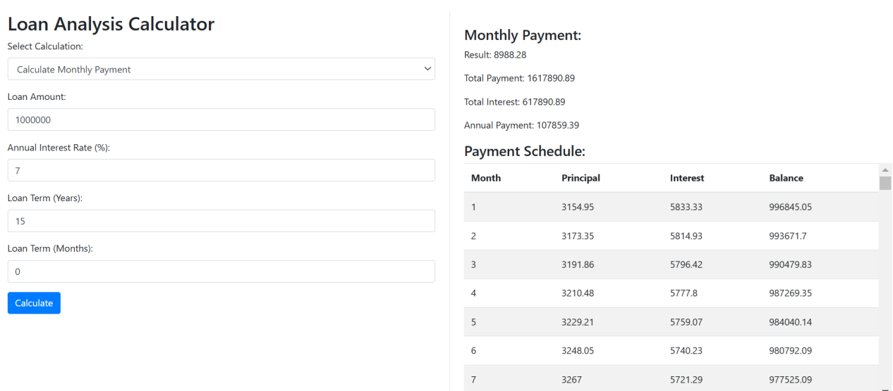

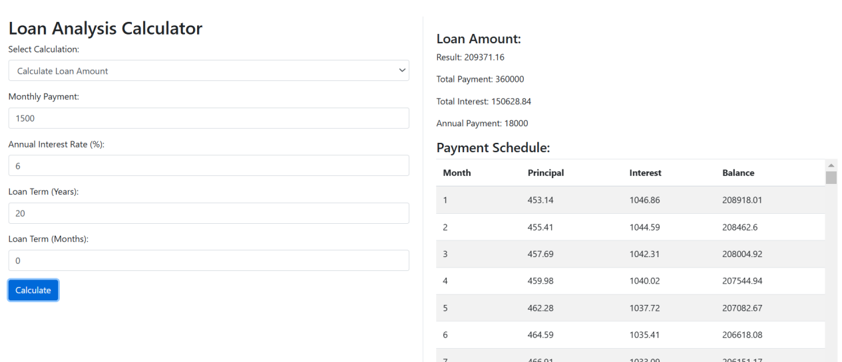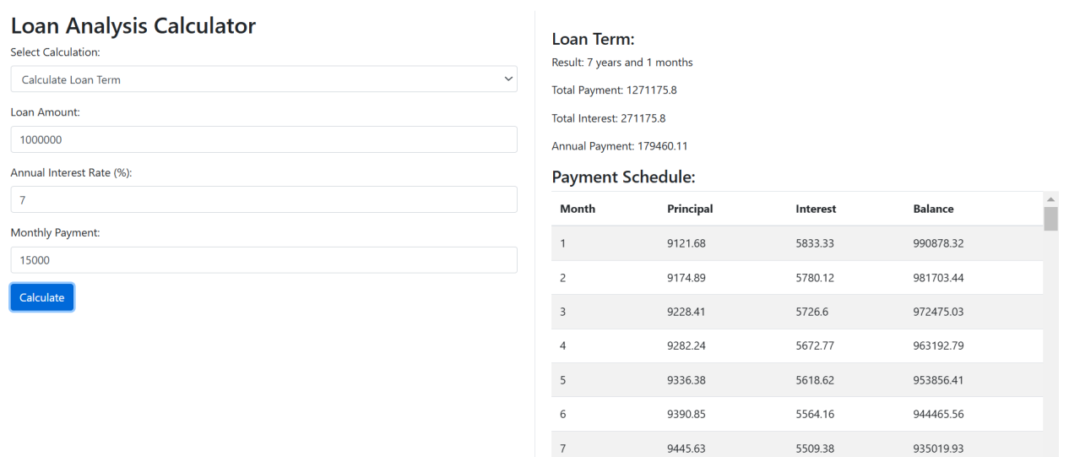

**- Retirement Planner Calculator**

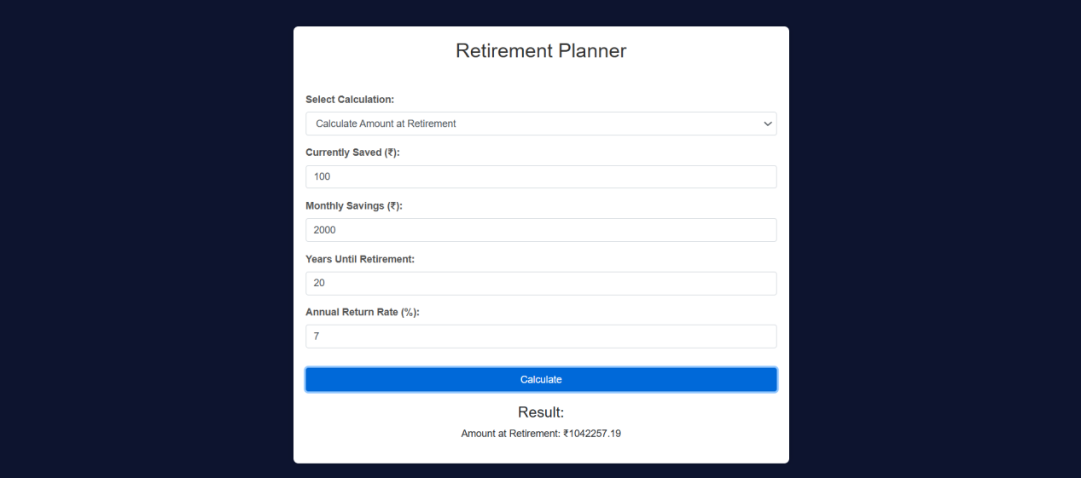

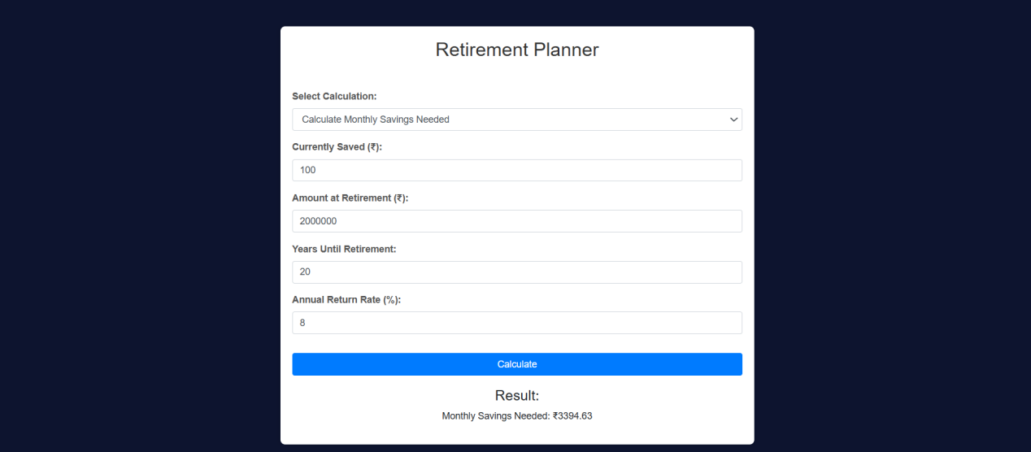

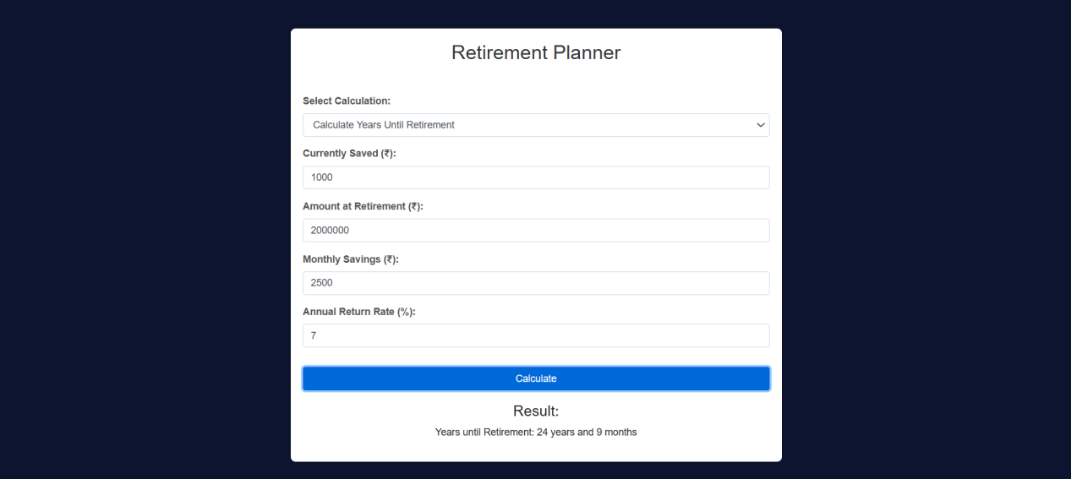

**- Tip Calculator**

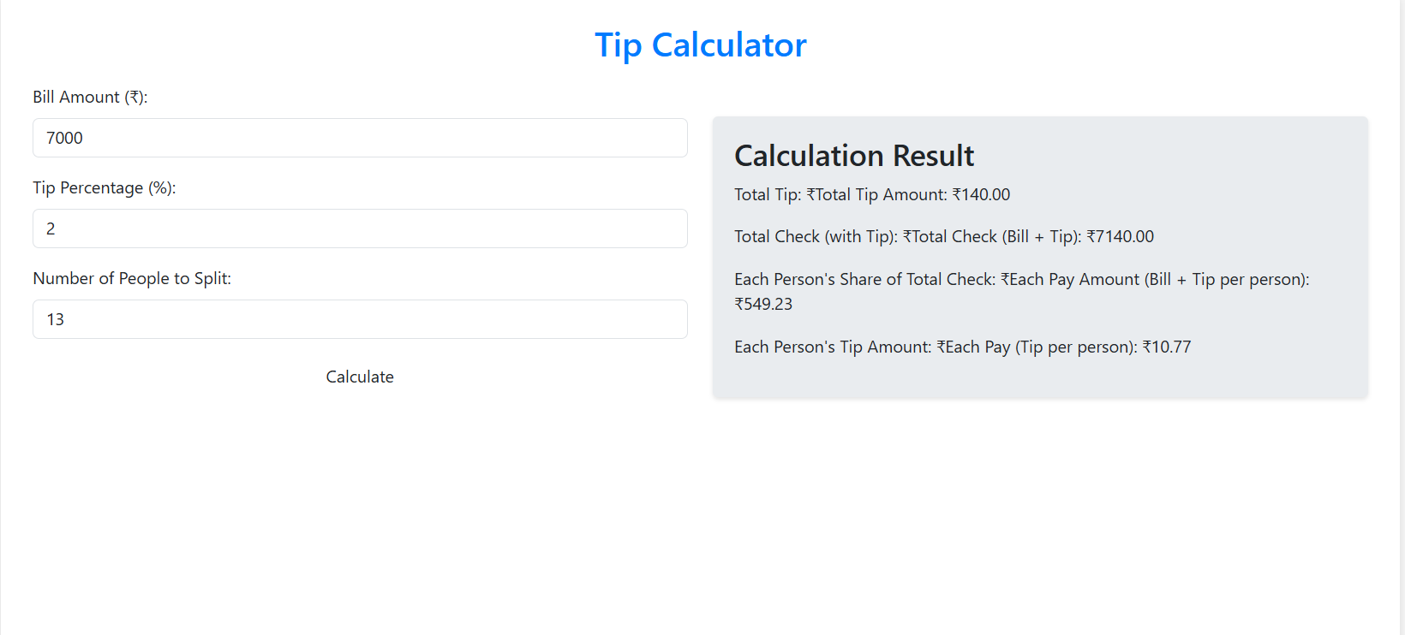

**- Stock Return Calculator**

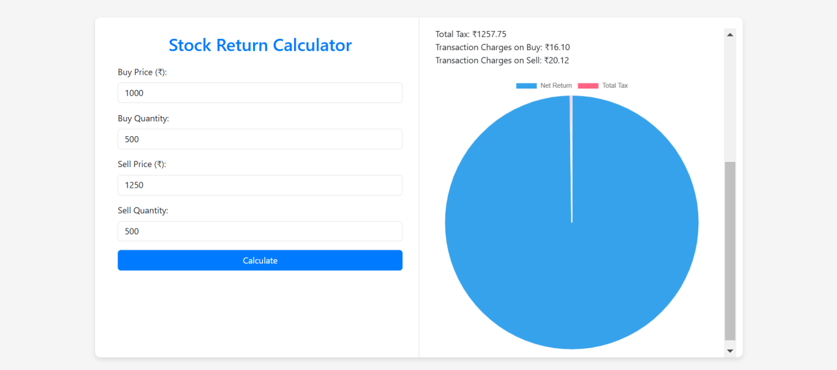

**- LumpSum Calculator**

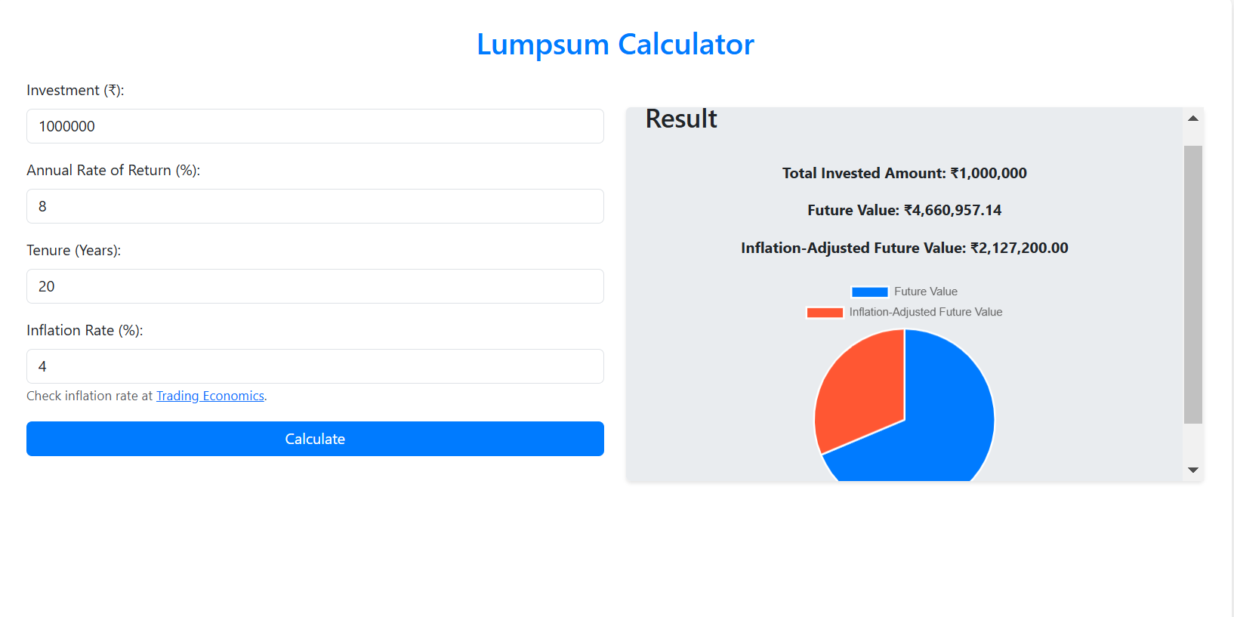

**- PPF Calculator**

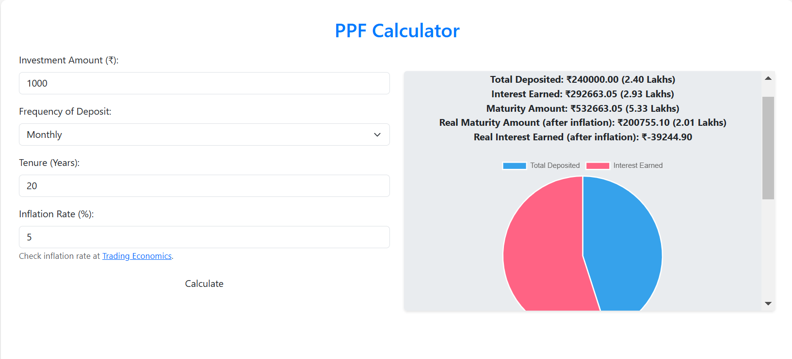

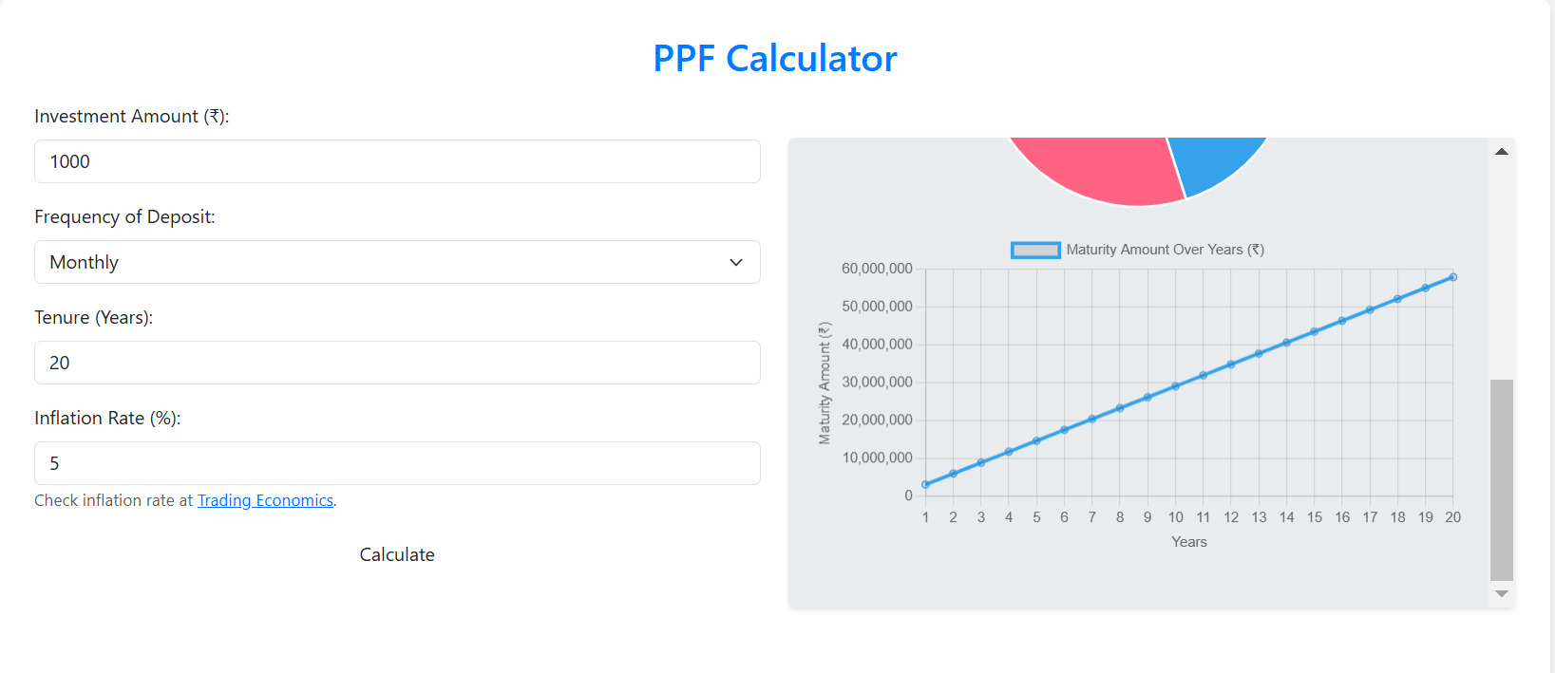

**- Step-Up Sip Calculator**

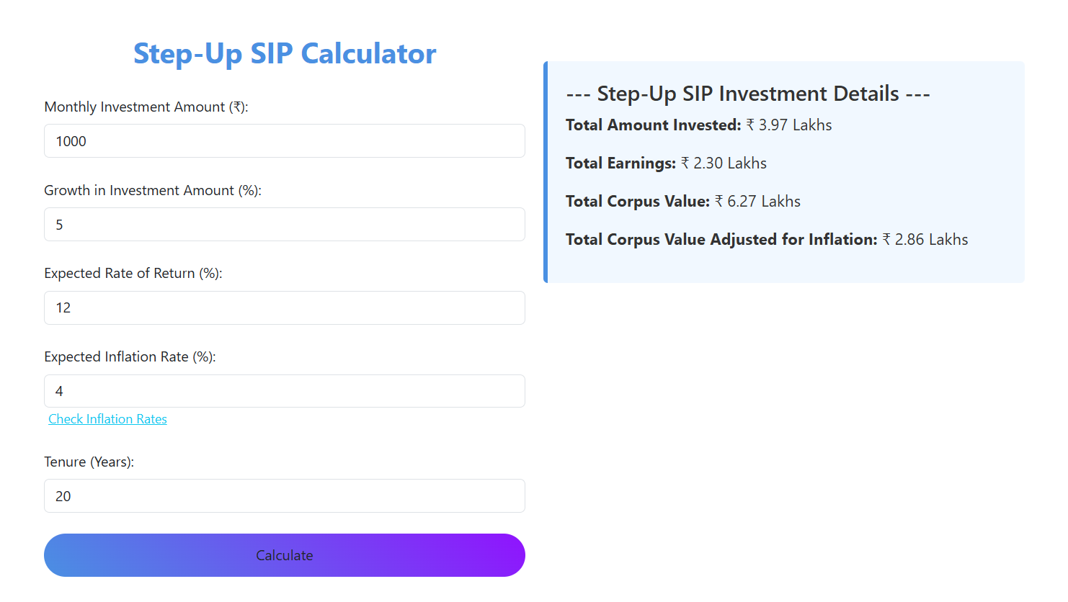

**- CAGR Calculator**

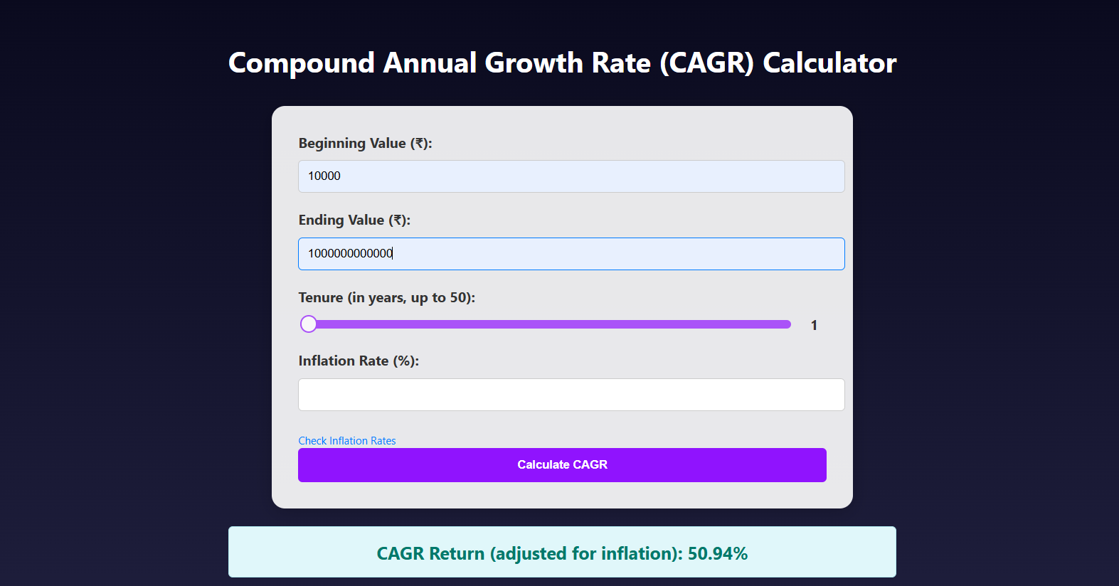

**- Sip Calculator**

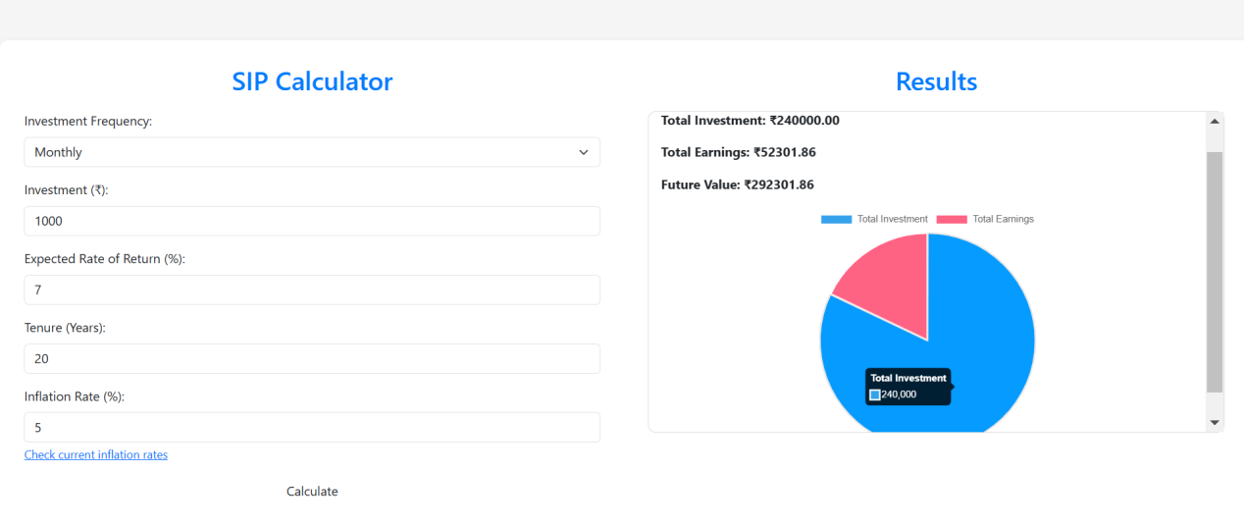

1. **Future Work**

* **Personalization to the End-User Customizable Inputs:** Enable users to save default values for common recurrences, such as savings (for example, preferred currency, or a loan amount).  
  User Profiles: Enable users to create accounts which can store the history of calculations they made, track preferences and even create financial goals.
* **Additional Functionality :** Investment Calculators Compute returns on investments (stocks, bonds, mutual funds) using different strategies.  
  Loan Comparison Tools: Let customers compare different loan products available across banks or institutions.  
  Calculators for Income Tax: Provide calculation tools for income tax based on different regions, such as tax slabs and deductions.  
  Retirement Planning Tools: Develop a calculator to help save enough money for retirement within the current income available. It will calculate the need for saving based on current income and anticipated requirements.
* **Data Integration:**  
  APIs can be used for more accurate and dynamic calculations regarding the real-time data streaming from stock markets, exchange rates, and so on.  
  Historical Data Analysis  
  Facilitate the analysis of historical performance data by allowing users in investment and tax-related calculators to obtain past stock prices or interest rates information.
* **User Interface/Experience Enhancement:**  
  Interactive Graphs/Charts- Provide investment or loan calculators with graphs or pie charts to make the output clear  
  Voice Input- Enable voice input for the user to speak their financial input instead of typing.  
  Theme Customization/Mode: Options for theme customization (e.g. dark/light mode) that would enhance the user experience
* **Advanced Analytical Tools:**  
  Predictive Models: Utilize machine learning to deliver financial predictions-for example, predicting loan repayment schedules or currency fluctuations  
  Risk Analysis: Include calculators to help users determine what risks come along with various financial decisions (for example, investments, loans).
* **Security Features:**  
  Data Privacy: Encryption of data about the users of sensitive kinds should be implemented if you plan on storing data such as financial records.  
  Multi-factor Authentication: To increase the levels of security, for accounts that carry sensitive financial data, you can add multi-factor authentication (MFA).
* **API Integrations:**  
  Banking API Integration: allow users to fetch their financial information-directly through APIs from their banks (for example, loan balance and credit card balance)  
  Crypto Calculator: Offer functionality for crypto investment, crypto tax calculations, and crypto-exchange rates.

1. **Conclusion**

Financial calculators are developed to make financial decision-making between an individual and an organization. An aim of this mini project was to design 15 calculators (one of which is a currency converter in order to enhance managing finances more easily. A simple yet user-friendly interface was designed while maintaining robustness and reliability for the backend calculations.

Financial calculators help to break down tough financial ideas into understandable terms. For instance, with a currency converter, one can easily get an exchange rate check, and the loan amortization and investment return estimators empower the user to make long-term financial decisions that have been decided with confidence.

The 15 calculators developed show varied application-in this regard, a simple arithmetic to the more complex financial modeling. Every tool is user-friendly so the average person who may know little about finance can easily use them. Easy labeling and intuitive navigation ensure efficient and accurate use.

Future versions may use real-time data input, such as stock prices, currency exchange rates, and interest rates, to make calculators more applicable to current financial choices. Personalization might be offered in the form of saving user preferences and introducing push notifications on those reminders related to finance matters. Accessibility can be heightened by supporting multiple languages and currencies.

Security will be critical in the financial applications. There must be a guarantee of strong encryption and authentications protocols to safeguard users' sensitive information.

1. **References**
2. <https://www.exchangerate-api.com/>
3. <https://zerodha.com/brokerage-calculator/#tab-equities>
4. <https://www.finology.in/>
5. <https://www.fncalculator.com/>
6. **Code**

<https://github.com/ShivaneshD/Financial-Calculators.git>